EXP:5
Non-preemptive Priority Scheduling
Note: Lower priority number means higher priority.
CODE:
#include <stdio.h>
int main(void) {
int bt[] = {
4, 3, 2
}, pr[] = {
2, 1, 3
}, p[] = {
1, 2, 3
}, n = 3, i, j, t, wt[3] = {
0
}
;
for (i = 0; i < n - 1; i++)
for (j = i + 1; j < n; j++)if (pr[i] > pr[j]) {
t = pr[i];
pr[i] = pr[j];
pr[j] = t;
t = bt[i];
bt[i] = bt[j];
bt[j] = t;
t = p[i];
p[i] = p[j];
p[j] = t;
}
puts("Process Priority Burst Waiting");
for (i = 0; i < n; i++) {
printf("P%d %d %d %d\n", p[i], pr[i], bt[i], wt[i]);
if (i < n - 1)
wt[i + 1] = wt[i] + bt[i];
}
return 0;
}
OUTPUT:
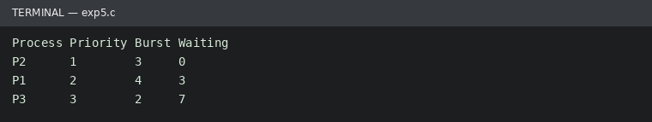
Run status: Ran successfully

